**Conservancy Revenue**

The Conservancy has two major sources of income. The primary source is water sales, and 23% of revenue is property tax that is dedicated for capital projects. At this time, loans to build new water towers are paid from property tax revenue.

In the 2024 budget, the tax collection is higher than previous years, however the overall tax rate   
did not increase very much due to higher assessed valuation on all property in the district. Individual freeholders may see a variance due to the relative increase of their own property.

As new commercial properties are constructed along State Road 43, there will be additional contribution to capital projects. The 2024 budget uses a small amount operating reserve in addition to the estimated sales revenue to provide sufficient appropriations for projects plus salary for a new professional employee.

**Review of Revenue**

**Income Charts**

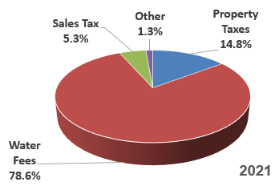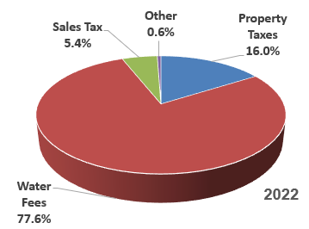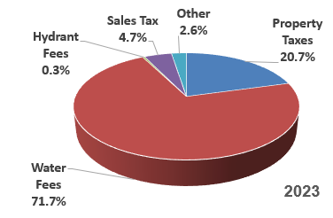

**Budgeted 2024 Revenue**



